
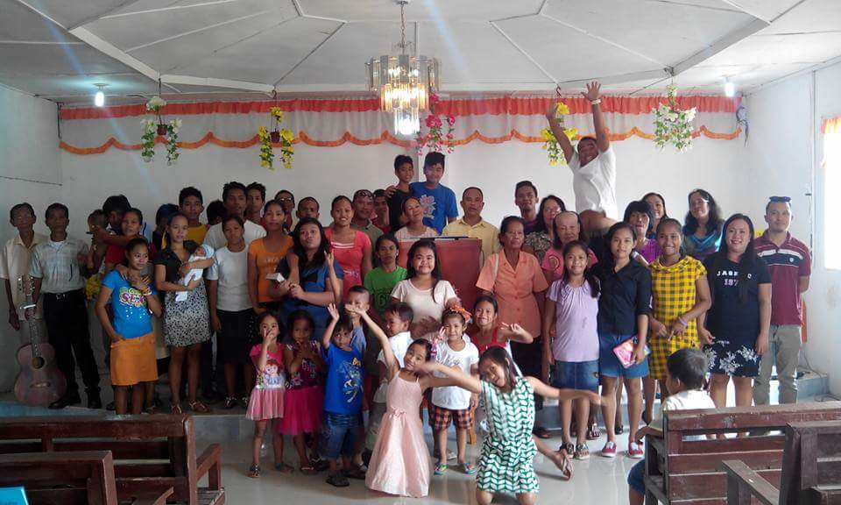
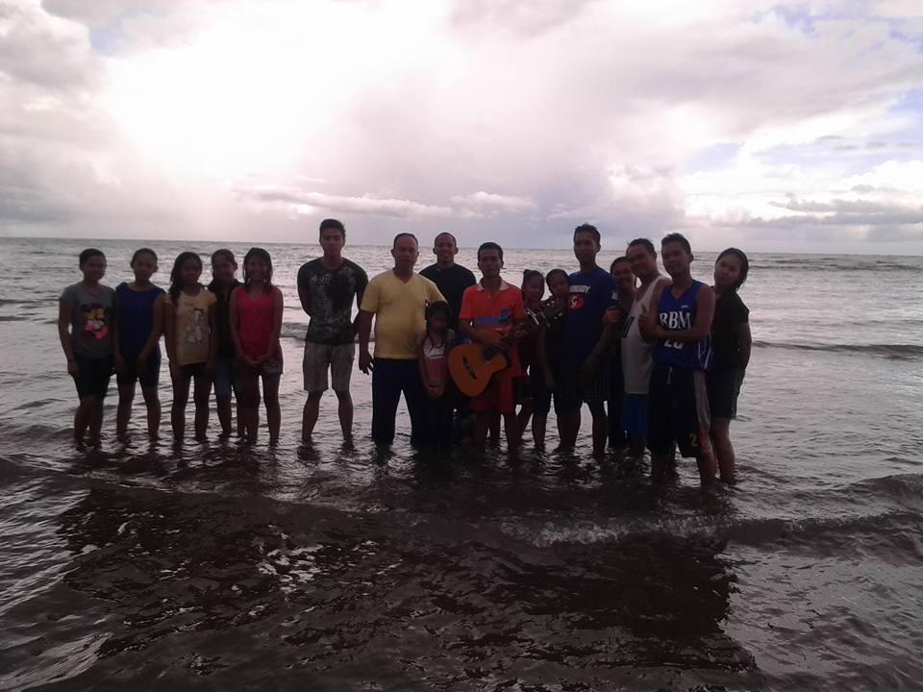
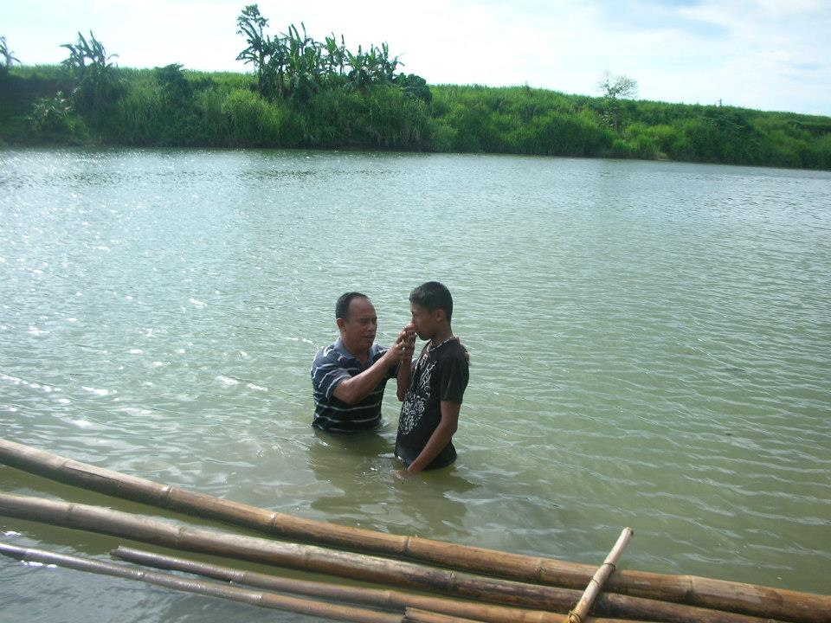
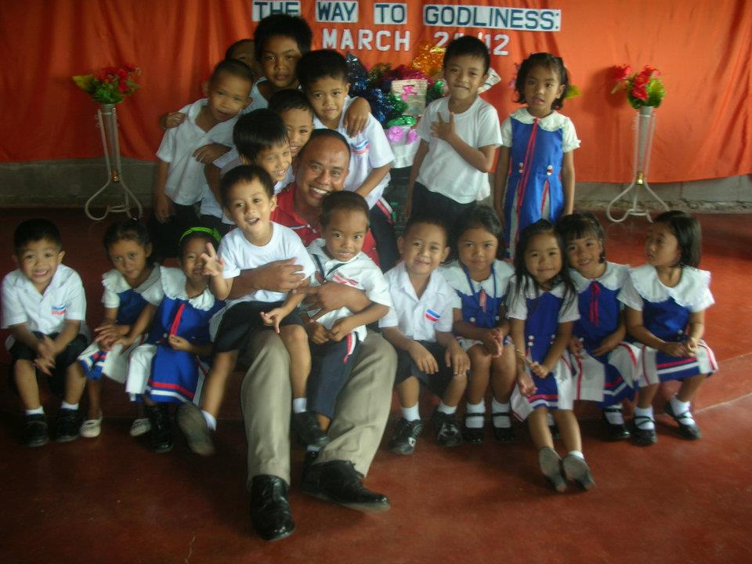
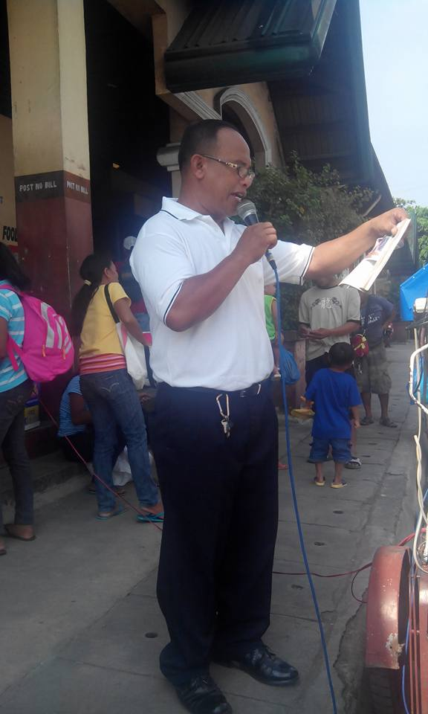
MINISTRY REPORT
PHILIPPINE AMERICAN ENHANCEMENT MINISTRY

January 29, 2016

To: PAME

Glory to God!
What a great blessings to be a partner in serving the Lord. Thank you for your monthly support to the missionaries, it’s a big help for them for the expansion of their ministry. Below are the update reports of missionaries.

Pastor Allan Dimpo
Bible Baptist Mission - Kabankalan
Kabankalan City

Pastor Allan ,Merly (wife) , Melanie (daughter) and Samuel (son).

Sunday Church Service

Baptism

Preaching the Word of God during Market day

Kinder School

Preaching the Word of God during Market day

Reports:
Total Number of Church Members -152
Total Number of Baptism year 2015 -26
Average Attendance in Sunday Service -57
Total areas of Bible Study -2
Average Attendance of Weekly Bible Study-33
Souls Saved

New Ministry in 2015:
Gospel Tracts Distribution
Preaching the Word of God during Market day
Discipleship Program
Kinder School

Reports:
Total Number of Church Members -152
Total Number of Baptism year 2015 -26
Average Attendance in Sunday Service -57
Total areas of Bible Study -2
Average Attendance of Weekly Bible Study-33
Souls Saved

New Ministry in 2015:
Gospel Tracts Distribution
Preaching the Word of God during Market day
Discipleship Program

Prayer Request: Church Transportation

