Pastor Hermoso Ayala

Bible Baptist Church

Giner St., La Castellana

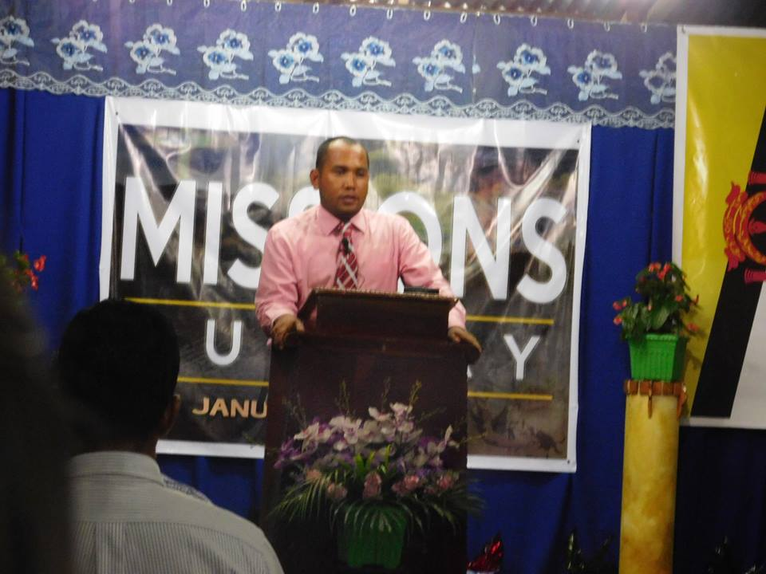

Assistant Pastor

Youth Pastor

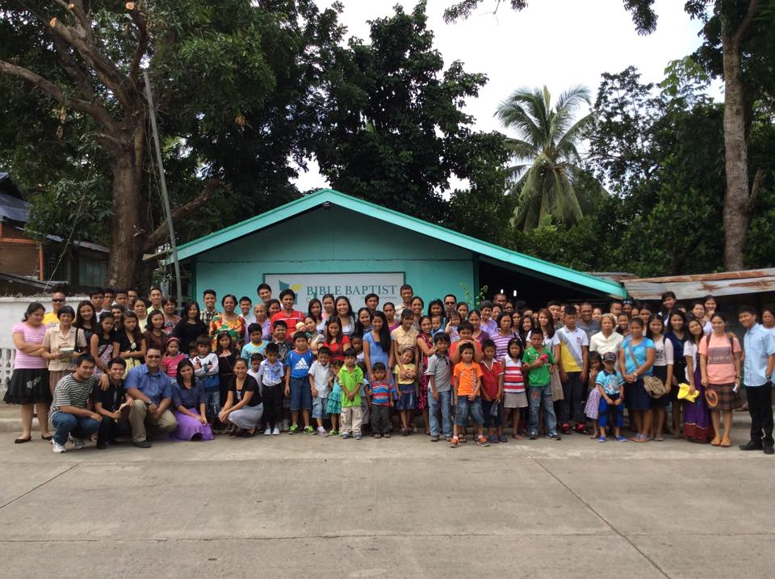

After Church Service

page 19

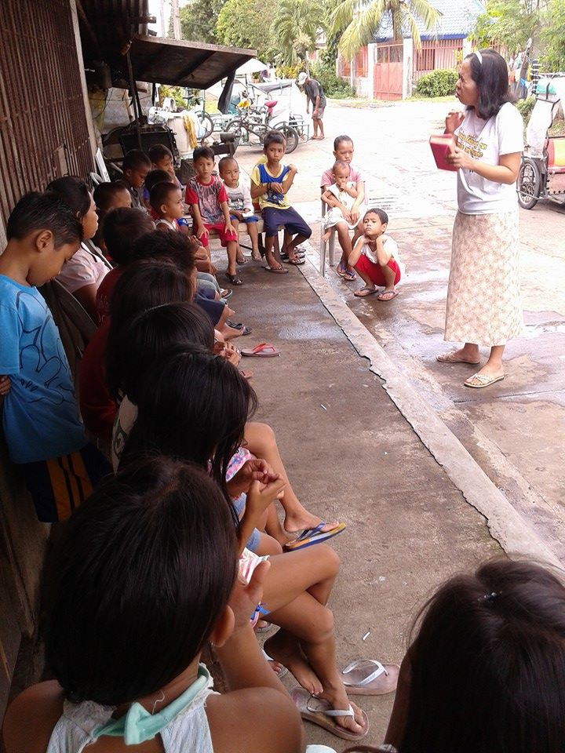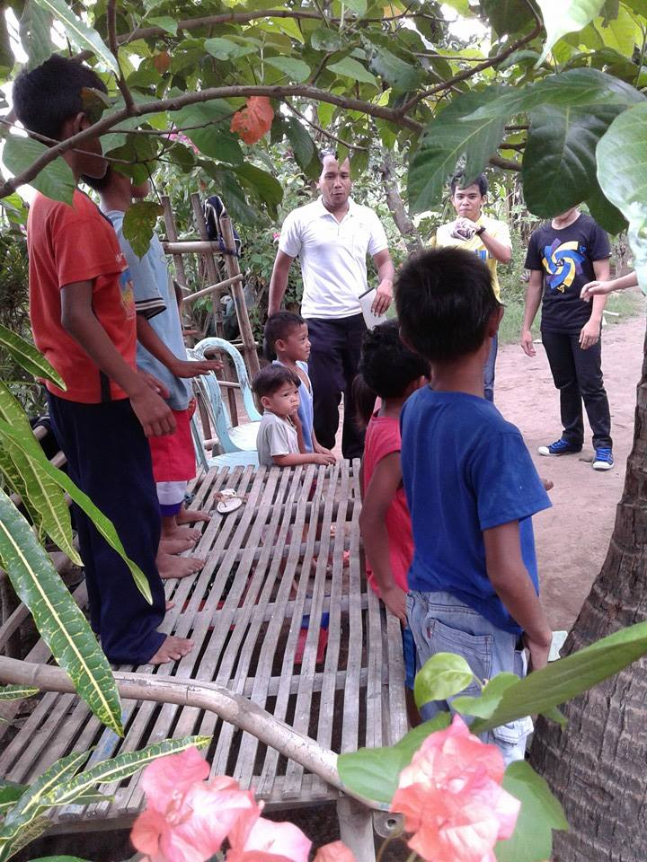

Saturday Extension Classes

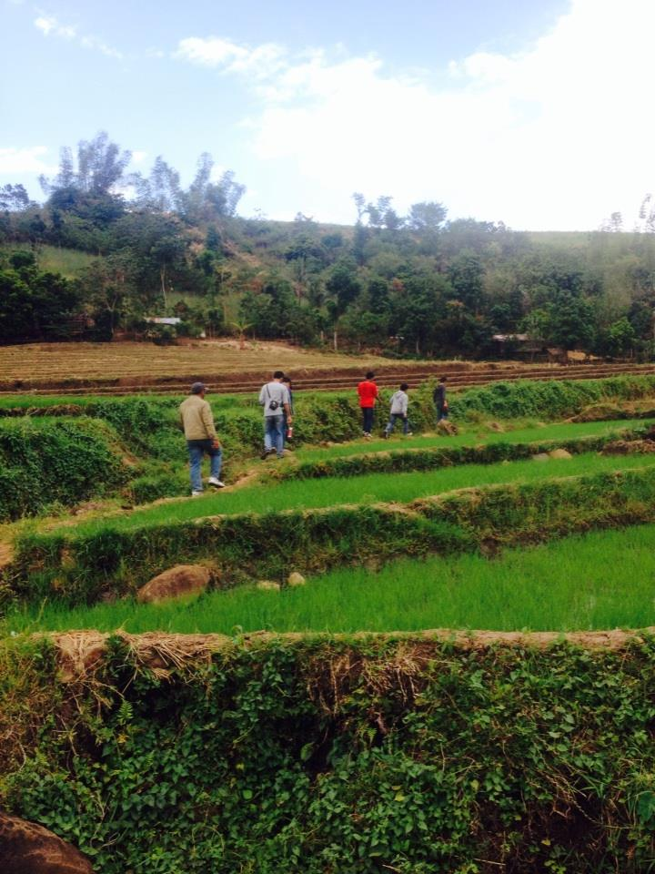 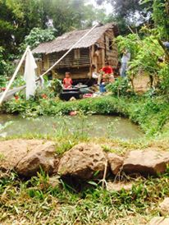

Saturday Visitation

Members up in the mountain walk 4 miles from their house

until to get transportation going to church.

page 20

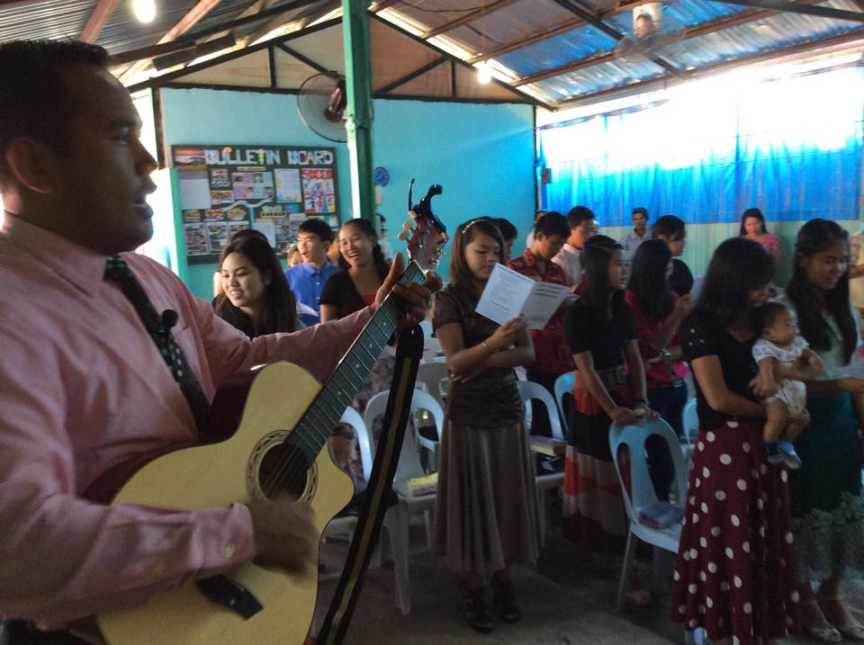

Sunday School

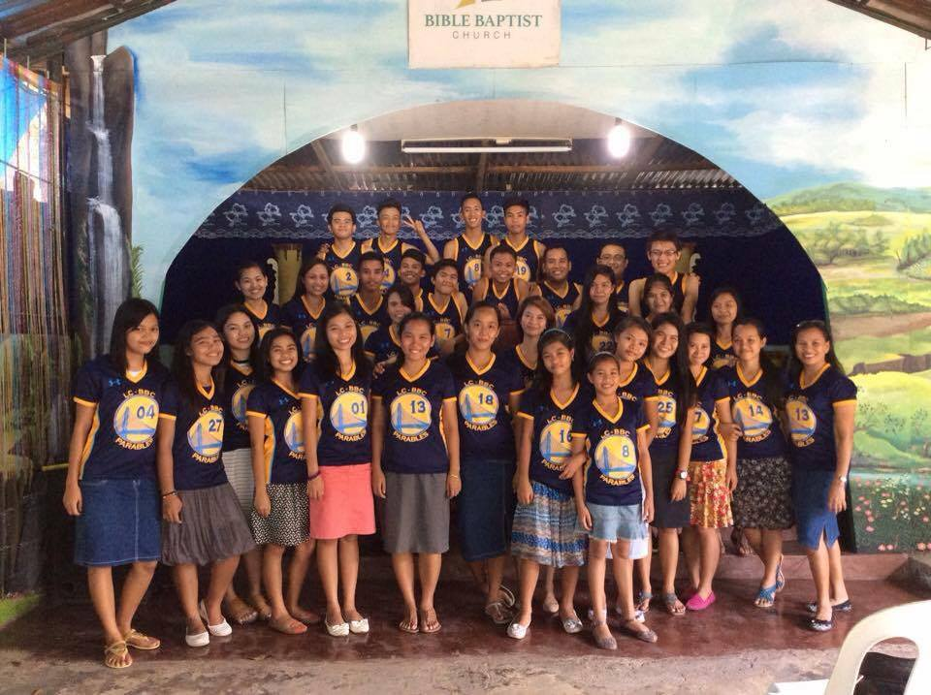

Young People

Reports:

Total Number of Church Membership-------400

Total Number of Baptism year 2015-----30

Total Areas of Bible Study - 2

Average Attendance of Weekly Bible Study-- 30

Average Attendance in Sunday Worship Service -----115

Souls Saved

Gospel Tracts Distribution

Campus Ministry

Prayer Request:

1) Church Lot

Page 21