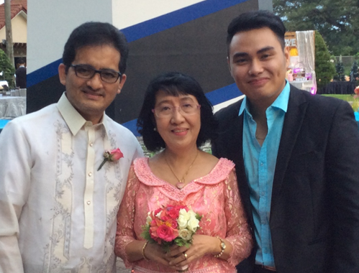

Leo Mary Sam

Your Missionary in Cambodia

Lifegate Baptist Church Updates

#45, St. 2011, Phnom Penh Thmey, Phnom Penh, Cambodia

Tel # (855) 16876011 Email drsleomary@hotmail.com

**Dear Dr. Cotter and Church, 3rd qtr ‘15**

**Greetings from Cambodia!**

**For the past fifteen years, our vision was our focus and through our partnership we remain in the harvest field. In spite of all the pressures and unpleasant situations, by the grace of God, we were able to achieve our goals and our mission persevered. It was a great blessing to see the fruits of our partnership.**

**Last July 26, 2015, Lifegate Baptist Church celebrated its 13th year of existence last July 26, 2015. We were so glad to have Pastor Emmanuel Subrabas, Pastor of Bible Baptist Church, Clarin and one of his men Bro Dan Navarro, our Church anniversary speakers with our theme “The Last Days”. It was also the first mission anniversaries of Lifegate Baptist Church in Takeo under the leadership of Pastor Santhor, Lifegate Baptist Church – Preyveng under Pastor Daniel and Lifegate Baptist Church – Khandal province under Pastor Makara. It’s a joy to see our local Missionaries working together for the realization of our vision fifteen years ago together with our Haley’s House of Hope children (3H). Glory to God in the highest.**

**Currently, 16 young people are studying in Bible College and Bible Institute who need our prayers. Rejoice with us for the 133 souls who made professions of faith and 7 baptized believers. With grateful hearts, thank you for your generosity, compassion and burden for missions.**



**3H Bible Institute Students Our speaker Pastor Subrabas LBC 13th church anniversary**

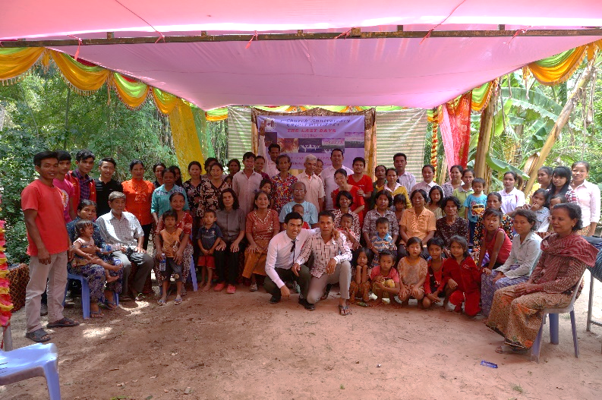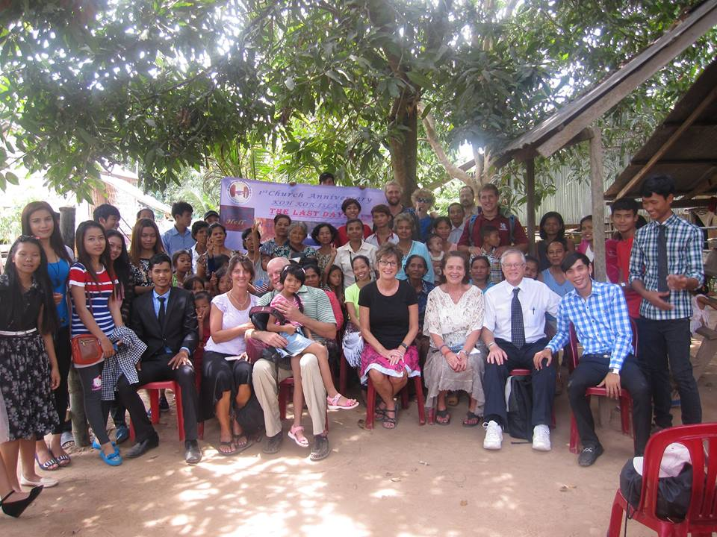

1st Mission Anniversary, Preyveng 1st Mission Anniversary, Khandal

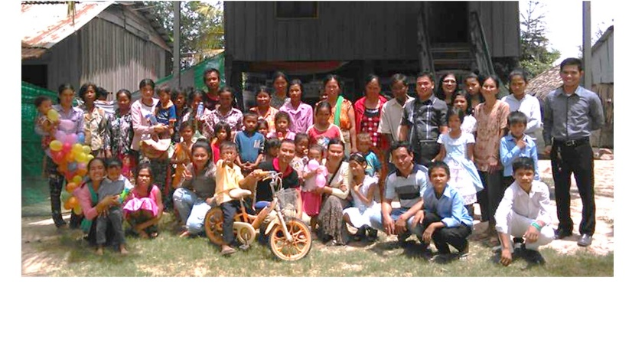

Support received July – Sept ‘15 $700

Prayer Requests:

1. More souls to be saved, baptized and serve the Lord.

2. God’s provision of our (17) Bible students. 3. Building needs in Preyveng and Khandal province

4. Monthly provisions of our needs

5. Wisdom for Lucro Piseth to reach his students

6. Campus ministry – Lucro Makara

TO GOD BE THE GLORY!!!

1st Mission Anniversary, Takeo