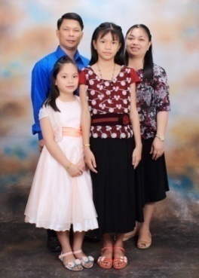 **THE JALANDONI'S**

Dear Pastor Gerard Cotter and Church Family,

"A Warmth greetings from Vietnam and Happy New Year to you!"

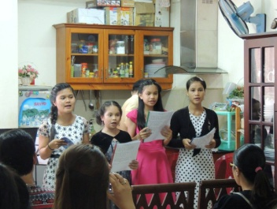 We gave all the praises and Glory to our loving and faithful God JESUS CHRIST for His abundant mercies and grace to us. As we welcomed the year of 2016, we would like to share our blessings from the field here in Restricted Access Nation; how God showed His miracles in changing lives and saving souls of many. We thanked the Lord for His answered prayers and helped, as He continually gave us new contacts and first time visitors in the church from the past other months. We're glad to met four College students named Tu, Let Let, Quynh and Tho; and young lady named Kim and another Filipino OFW named Ging. These Vietnamese ladies had joined our English Discipleship Class and had been attending our church service for almost a month. And we praised God that Let Let and Kim believed and accepted the Lord JESUS as their personal Lord and Saviour last December 06, 2015. Though some of the ladies did not profess yet but we kept them in our daily prayers and taught them more about the Lord JESUS.

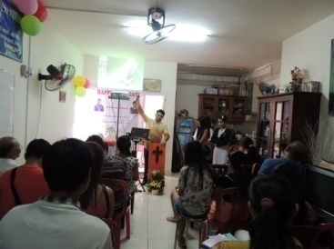

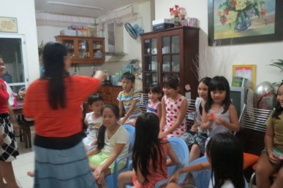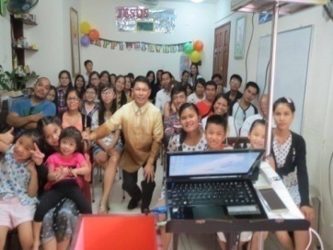 Last December 06, 2015 was our Pastor's Appreciation Sunday; we celebrated my 40th Birthday and also the 11th birthday of our eldest daughter Kezia Pauline. Through the cooperation and effort of the members and church workers, we had an attendance of 46 people in our house church in spite of the fact that sometimes there are policemen checking around and guards are everywhere keeping an eye on every blocks and buildings especially on the months where there are celebrations. But we gave all the glory to God in spite of these circumstances; nothing can stopped for the 9 souls who accepted the Lord JESUS CHRIST in their hearts and 1 Filipina Muslim turned her heart to the Lordship of the Lord Jesus Christ. What a great joy to see her! At the last part of my preaching as I looked at her, her whole body and her hands was trembling and shaking as I saw her convicted and moved by the Holy Spirit through the Living Word of God and she’s the first person who publicly raised her hands and stood up, turned herself without hesitation to our Great God and Saviour Jesus Christ accepting Him. What an Honour to serve the Lord in this country of Vietnam! He is still working. "The Lord is lifted up and exalted. “He must increase and I must decrease." He is glorified in what He is doing and nothing good in me. All we can say is “To GOD be the Glory!” We keep praying that they will be added to the church in God's time. God is good all the time! His love and truth are everlasting! Last Dec. 27, 2015 was our Year End Fellowship after our church service, and we praised God and the working power of the Holy Spirit that worked in the lives of our attendees who were newly saved as they gave testimonies of what experiences they have when they put their trust in the lord JESUS. We had also Gift Giving to the children in our Sunday school and most of them already accepted the Lord Jesus Christ although their parents are Buddhist and some was government officials. We also thanked the Lord that Elika our youngest daughter made her decision to be baptized last Jan. 03, 2016. We are truly humbled how God touched our children's heart that at the young age they want to serve and follow the Lord. These are our greatest joy and treasures that can't be bought. This wonderful blessings we had is all because of your prayers, love, concern, and sacrificial giving for the Lord's work. A nation that has been blinded from buddhism, confucianism, paganism, hinduism, and more...it is only by God's power that can change someone's lives and saving them from the darkness of sins.

May you will continue to uphold us in your prayers that more souls will be reached out this 2016. More souls will commit to the Lord in water baptism and will be added to the church. Please include in your prayers also our two Vietnamese church workers Mi Ell and Mi Chen of their burden to reach out another tribe next to their village on the highlands of Vietnam during their two weeks break on February due to the Chinese New Year, Pray for the motorcycle to be used in follow up and visitation. We had a lot of awaited church activities on this month and also our upcoming 7th Church Mission Anniversary on March 2016. May you'll continue to pray for our needs for the processing of one year visa extension for my wife and two daughters on this month of January, though I already have a 1 year visa but except for them.

Thank you all for your undying love, prayers and financial support that you sent us every month. They are a great and big help for the work here in Ho Chi Minh City, Vietnam. From the bottom of our hearts...thank you very much and we're all praying for you, too. God bless you!

Your labourers in VN,

( Melvin, Julie Ann, Kezia Pauline and Elika Emerald)

**Jalandoni's Family**

Support Received: (Love gift-)

**November 2015: 100 Usd December 2015: 100 Usd.**

**Personal Info:** Email: [jalame_july@yahoo.com](mailto:jalame_july@yahoo.com), [juls_jal@yahoo.com](mailto:juls_jal@yahoo.com)

Contact: Vn. (+84) 935-531-405

**Sending Pastor/Church**: **Pastor Ferdinand Magallanes** / ***Open Bible Baptist Church***

Puentebella Subd. Brgy,,Taculing Bacolod City, Negros Occ. Phils.

**Support Address:** ASIAN BAPTIST CLEARINGHOUSE  
 P.O. Box 14231 Ortigas Center CPO,Pasig City 1605, Philippines

E**mail:abclear@abclear.org**