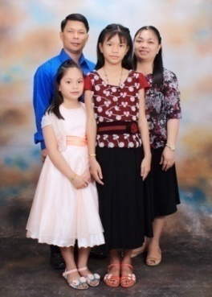 THE JALANDONI'S

April- June 2016

Dear Pastor Gerald Cotter and Church Family,

Greetings from your church family here in OBBC-VN!

***"They are new every morning: great is thy faithfulness."*** **Lamentations 3:23**

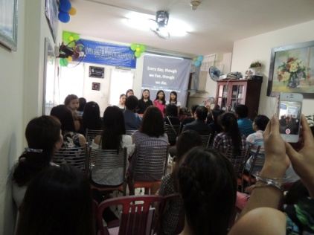 Truly God was faithful in our lives throughout these nine years that we've been in the mission field. Everyday are new beginnings, there are new challenges, new opportunities, and more in serving Him in this Restricted Access Nation. What we are right now is only by His grace, only by His mercy, and only by His wondrous help and miracles and not by ourselves. Serving in this Restricted Access Nation was really hard especially with the language barriers but it is the LORD who helped us and gave people to His church. Our hearts were amazed and blessed how God touched and transformed people's lives from buddhism into Christianity. We are truly grateful to God as well as to your church and to our mission partners who never quit in extending your help financially and most of all for praying for the safety of our family here in Ho Chi Minh City.

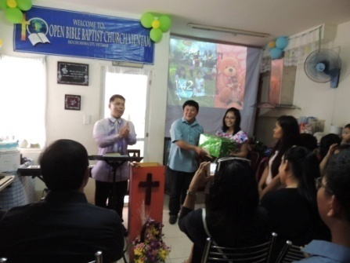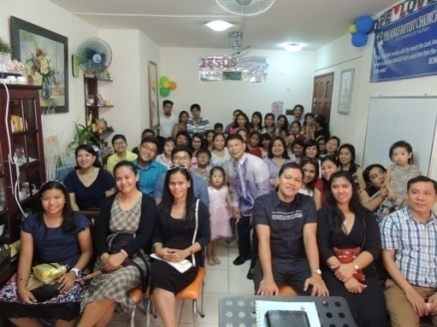 God was great! We praised him for the victories we had during our 7th Church Mission Anniversary last April 3, 2016. We had 68 in attendance, 14 kids in our English Sunday School, and with 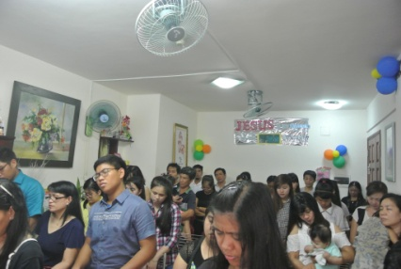6 first time visitors who most of them are buddhists and few Filipino attendees. We are thankful of the privilege that we are able to invite kids to our English class along with their parents and these kids gave a special song, "Jesus Loves Me" in English and Vietnamese. And also we are blessed of the souls who accepted JESUS CHRIST as their Lord and Savior. Mr. Quang is one of those who publicly accepted the Lord JESUS in his heart and after our service during the lunch fellowship, he came to me and told me that he was so happy that he attended our service and that he heard about God and how everyone welcomed him and befriend him. He said that he felt peace in his heart when he was listening during the preaching that he never ever heard before in his entire life. And when he will come back again, he even wanted to bring his wife and children also to church so they could also listen about God. When I heard it from him, my heart was filled with great joy how the Spirit of God moved in him. May you will help us to pray for Mr. Quang and his family that his wife will also open her heart to the Gospel and may God will give us wisdom to follow up this family. Please help us to pray that more souls will be baptized and will be added to His church. We had six young people that was newly saved but still they're undecided to obey God in water baptism because of fear of family persecutions; and also two families who were attending our service many times...may the Spirit of God will give them the courage and obedience to the Lord Jesus. And we are thankful also for these four college students, named Thu, Kim, Tu, and Trang that we ministered in our English Discipleship Class that now started to attend our church service on Sundays. We're praying that they will made their decision to follow in water baptism in a proper time. One of our blessings also that we're able to spend time with Mai Anh before she left to Japan that she brought her mom to the church. She's one of our faithful young people along with her older sister Tram Anh who finished her Masters Degree in Switzerland. We are so grateful that she married a Christian Vietnamese and now both of them are faithfully attending the church in Osaka, Japan.

Please include us in your prayers about our desires for the furtherance of the ministry and the Gospel in this Restricted Access Nation here in Vietnam. Me and my wife had been praying to open up an English Language Center for all ages whose willing to study and practice English and also a Preschool using the ACE/SOT curriculum in our neighbourhood. The main goal of this plan is to reach out parents, children, and young people for the Lord, to teach the children in their early age about God and introducing them the way of the Lord so that it will reflect in their ways and Life and their parents would see the different training in the way of the Lord and also we'll use this method as our front that we have the school in name but actually we do a house church ministries; especially at this point, that the Government of Vietnam are pushing their people to study English as their second language and we Filipinos has the capacity to teach them the basic communication skills as well as to slowly introduce them to the Gospel. We may be needing a large amount of finances to rent a larger place for the church growth of people and for the school and to buy the necessary furniture or equipments but we know that God will provide for this is for His glory and ministry. Thank you for your prayers and support always, it meant a lot for us here. God Bless you all.

Yours for the Souls in VN,

The JALANDONI's Family

(Bro. Melvin, Sis. Julie, Kezia & Elika)

Support Received: (Love gift-)

**January 2016: 100 USD February 2016: 100 USD March 2016: 100 USD**

**Personal Info:** Email: [jalame_july@yahoo.com](mailto:jalame_july@yahoo.com), [juls_jal@yahoo.com](mailto:juls_jal@yahoo.com)

Contact: Vn. (+84) 935-531-405

**Sending Pastor/Church**: **Pastor Ferdinand Magallanes** / ***Open Bible Baptist Church***

Puentebella Subd. Brgy,,Taculing Bacolod City, Negros Occ. Phils.

**Support Address:** ASIAN BAPTIST CLEARINGHOUSE  
 P.O. Box 14231 Ortigas Center CPO,Pasig City 1605, Philippines

E**mail:abclear@abclear.org**