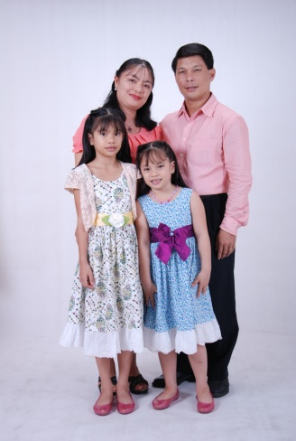 THE JALANDONI

December 12, 2014

Dear Pastor Gerard Cotter and Family,

Greetings from VN!

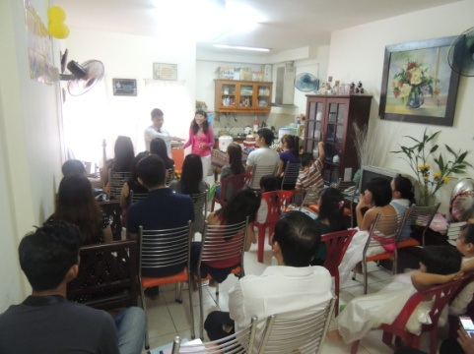 A warmth greeting from our Great Almighty God whom we serve with our whole heart. Gratefully we would love to share the many blessings God bestowed to us on this month of December. Before the year 2014 will end, we looked back on how privilege we are to serve the Lord and to experience His unfailing and unending grace, love, mercy and abundant faithfulness. What a great God we had! His love and joy is our strength daily in our lives.

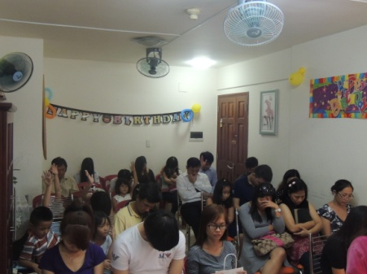 Last December 7th, is our Pastor’s Sunday as well as the birthday celebration of our eldest daughter Kezia Pauline. God gave us visitors more than we had expected. Our house was full packed, we are 42 in attendance and we thanked the Holy Spirit how he moved in the hearts of our friends and visitors; there were 9 people who publicly received the Lord Jesus to be their Lord and Savior. It melted our hearts…we are humbled of God’s loving grace, just to see those hands raised high, they are willing to accept the Lord Jesus and believed with their whole heart is what a great joy! A nation who was deeply influenced by Buddhism, Taoism, Hinduism, ancestral worship, and many more…so even just one soul who will believe and will accept the Lord Jesus is a great victory. We thanked the Lord, too that we had baptism last Dec. 6, 2014. We are so grateful that one lady followed the Lord in water baptism. We thanked the Lord for her dedications and love to our dear Lord. Please include also these five young Vietnamese: Tram, Huyen, Tu(Henry), Trang, Phuong; also one couple named Mr. Hong and his wife Lam and also five Filipino OFWs. They had accepted the Lord in their hearts; we are praying that they will also follow in water baptism.

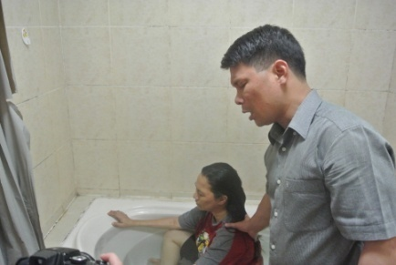 You all have a great part in this endeavor. Your prayers, love, concern and financial help are not in vain. These precious souls will someday be with us in heaven and that would be a great reunion! From the bottom of our hearts, we thanked you all for partnering with us and for supporting the Lord’s work here in Ho Chi Minh City. We appreciate all your labor of love and your generosity. God will surely bless your effort and your sacrifices for Him and for His laborers in the vineyard. Thank you so much and God bless you, your dear family and the ministry.

**URGENT PRAYER REQUESTS!**

Let me share a concern and burden that we struggled at this time. This year, Vietnam’s government policy is strictly; tighten hard about the Visa for the foreigners. Last month, we are all alarmed that starting the month of December 2014 will be harder to get a new visa or extension. Before, we can get 3 months visa then you can extend for another 3 months; after 1 extension you have to exit to the border and stayed for hours and can come back right away. But this time, is more harder, in order to have 3 months visa you need some legal requirements, but the worst is, after your visa ended, you have to exit and cannot come back as what we did before but you have to stay in a place where you exited for weeks or a month we don’t know yet but the issue is you cannot come back right away, and it become more expensive and strict concerning legal papers which we don’t have for that. The last year and couples of month the visa for 3 month’s single entry for 1 person is 67 USD and we paid 268 USD for 4 of us every 3 months. 268 USD multiply by 4 again for the whole year is 1,072 USD. But starting this month the price will be doubled. But the blessing is I met a Christian lady which she has connection and a business, partnering with a high profile Vietnamese official, she told us that she can help us to get a (TRC) or temporary residence certificate under her business company and her legal papers which the price is reasonable. She told us (TRC) is much cheaper in a computation, she can give us 3 years TRC with the amount of 480 USD per person for 3 years. We pray that churches can help us and share a little amount.

We pray that this may not misunderstood us but may you will include us in this urgent prayer requests that God will supply our financial needs to whom God perfectly and appointedly work.

Laboring for souls in VN,

The JALANDONI’s

(Melvin, Julie Ann, Kezia Pauline and Elika Emerald)

Support Received 2014:

**September: 100 Usd October: 100 Usd November : 100 Usd**

Sending Pastor/Church: **Pastor Ferdinand Magallanes** / ***Open Bible Baptist Church***

Puentebella Subd. Brgy,,Taculing Bacolod City, Negros Occ. Phils.