Ptr. Neil Escanillan

Banquerohan Bible Baptist Mission

Banquerohan, Cadiz City



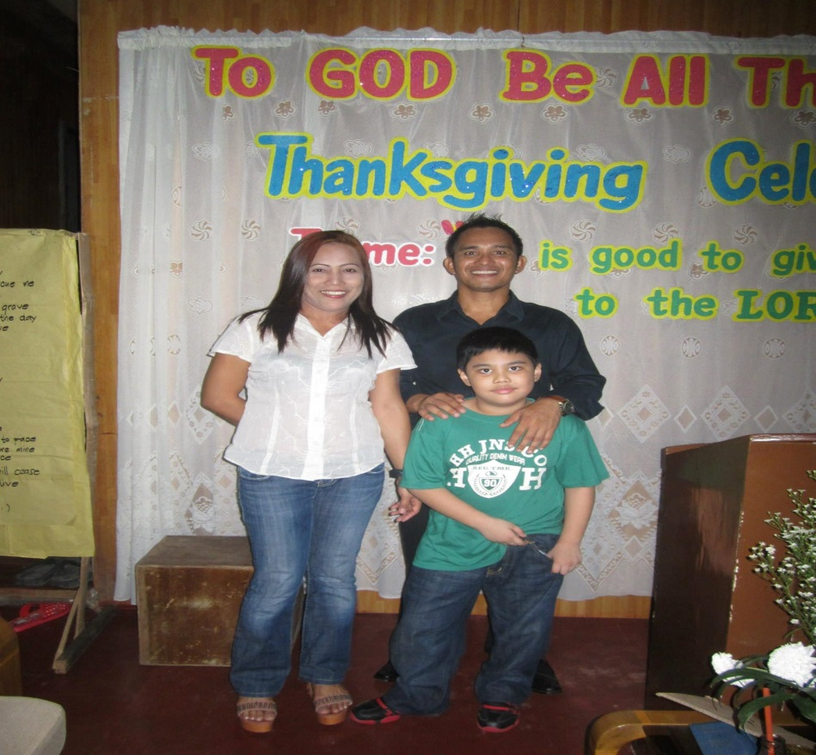

Pastor Neil and his family

page 16

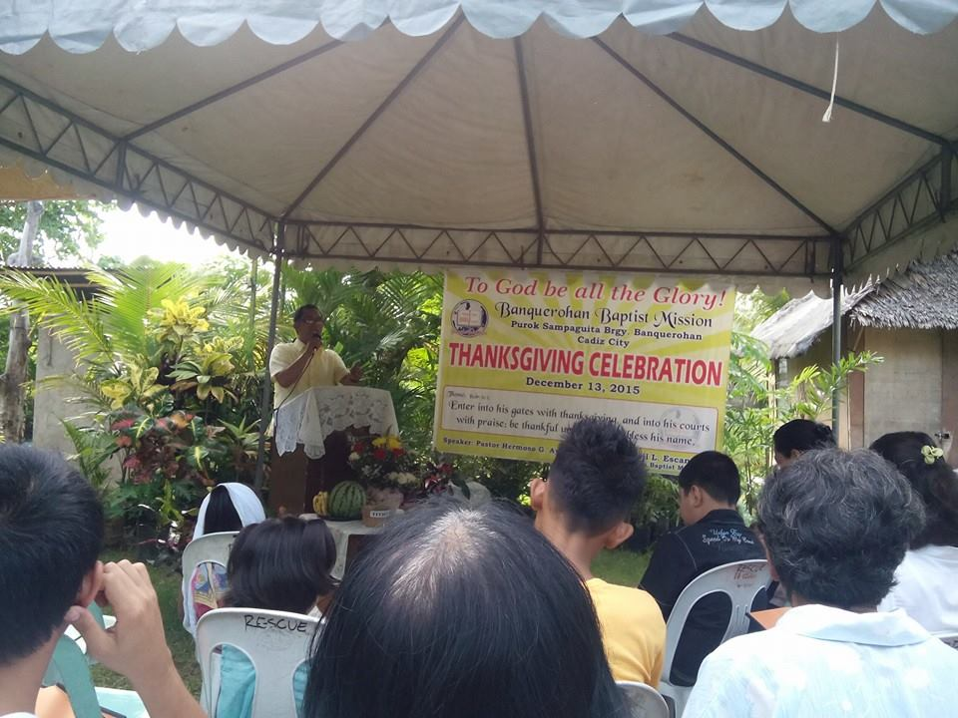

Reports:

Total Number of Membership - 30

Total Number of Baptism this year— 23

Total Areas of Bible Study— 2

Total weekly Attendance in Bible Study -20

Gospel Tracts Distribution

Prayer Request:

1) Church building materials

2) Members faithfulness

3) Prospect for baptism

page 17