Pastor Vither Lapore

Gethsemane Bible Baptist Mission

Brgy. Alijis, Bacolod City

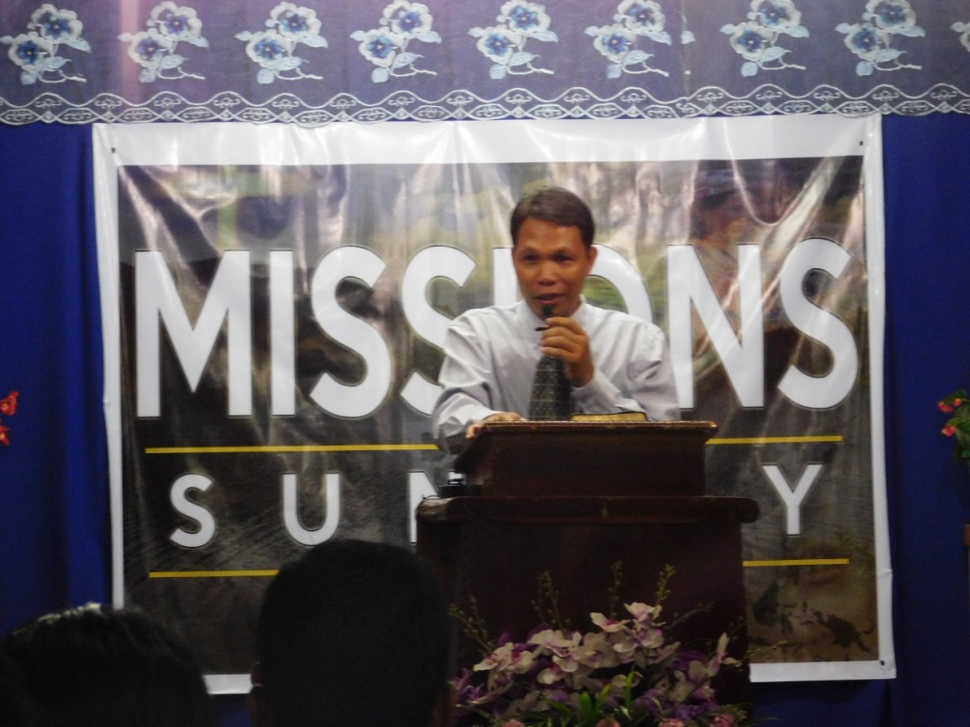

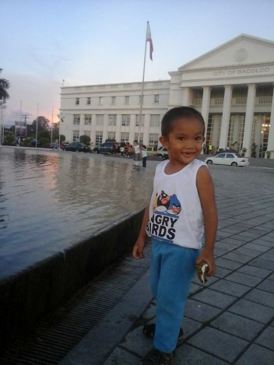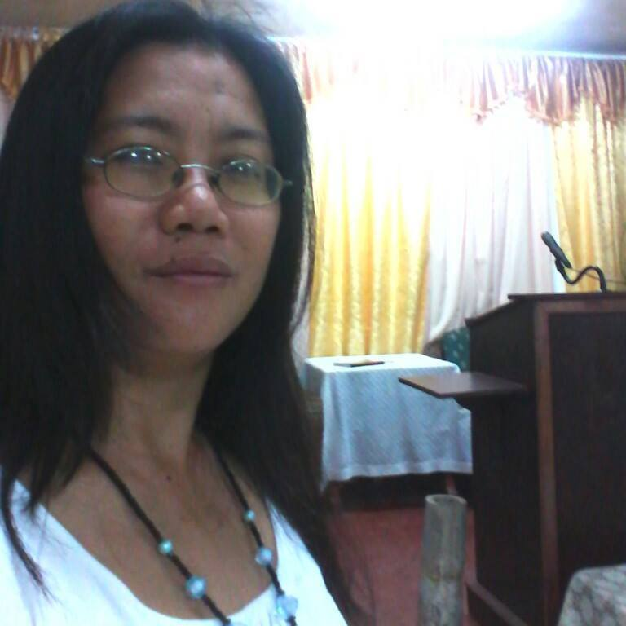

Ptr. Vither , Maricar (wife) and their siblings

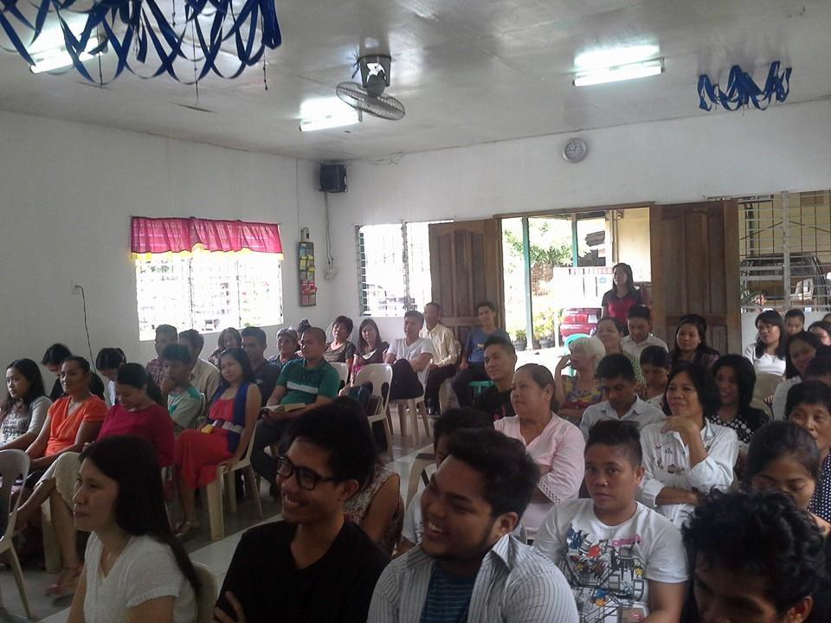

Sunday Church Service

page 25

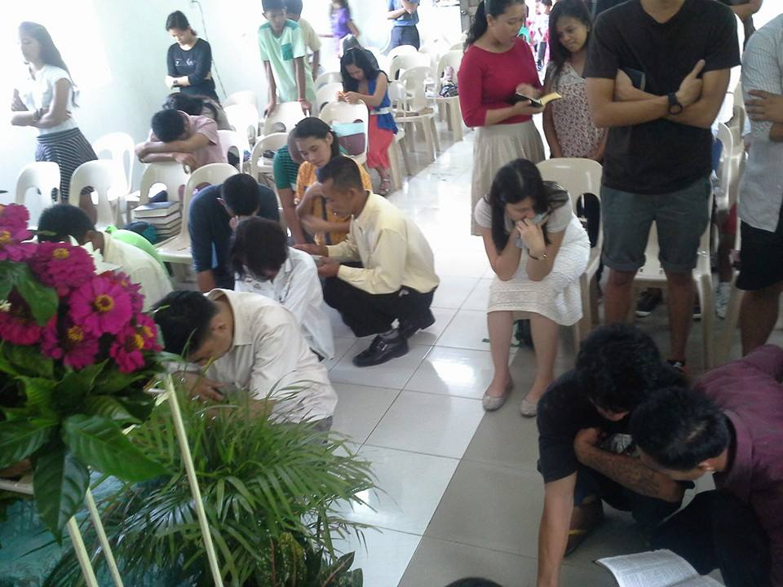

Baptism

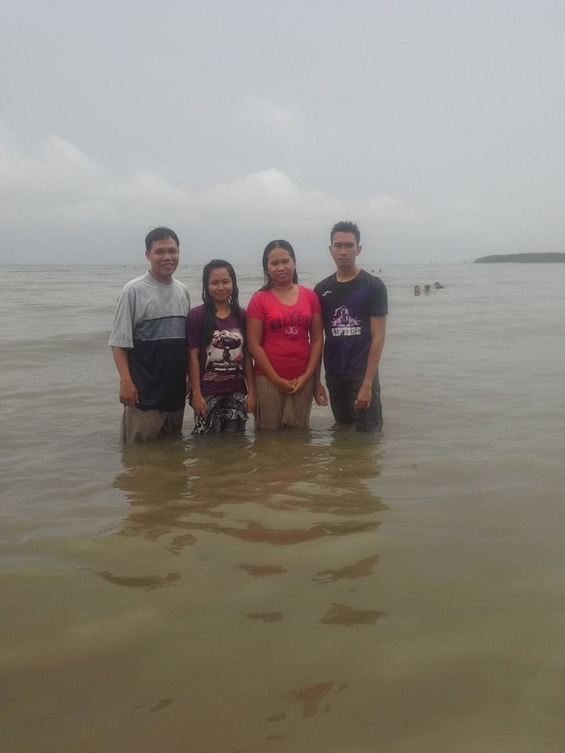

page 26

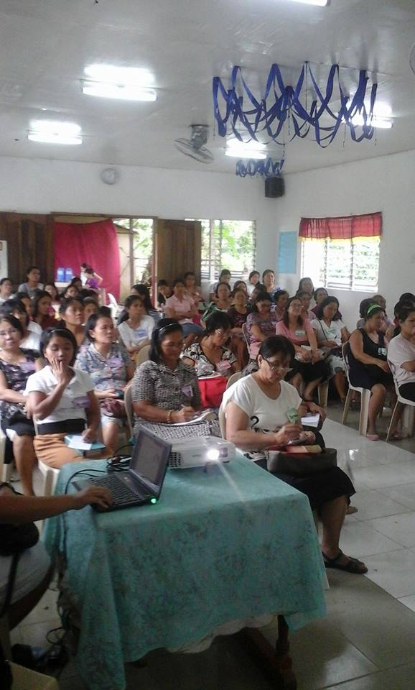

Women’s Fellowship

Reports:

Total Number of Church Members- 243

Total Number of Baptism in 2015- 11

Total Areas of Bible Study -2

Average Attendance of Weekly Bible Study-23

Average Attendance in Sunday Service- 39

Souls Saved

Prayer Request:

1) Praying and working for an Outreach Ministry

2) Building projects:

Renovation of comfort room

Repair of roofing

3) School Ministry

4) Youth Leader

5) Computer set

6) Outreach program

page 27

God is good. For the whole year (2015) most of our missionaries have additional activities to their ministry. Your support and prayers are great encouragement for them to do more in serving God. We can see their passion to spread out the Gospel and reaching the lost souls to be saved. We know that being a full time in the ministry it’s not easy. Please continue to pray each of the missionaries and their families.

Thank you very much and God bless us.

Prepare by : Marilou Remoting

marilouremoting@yahoo.com